**RESULTS:**

**Frontend:**

**Backend DB:**

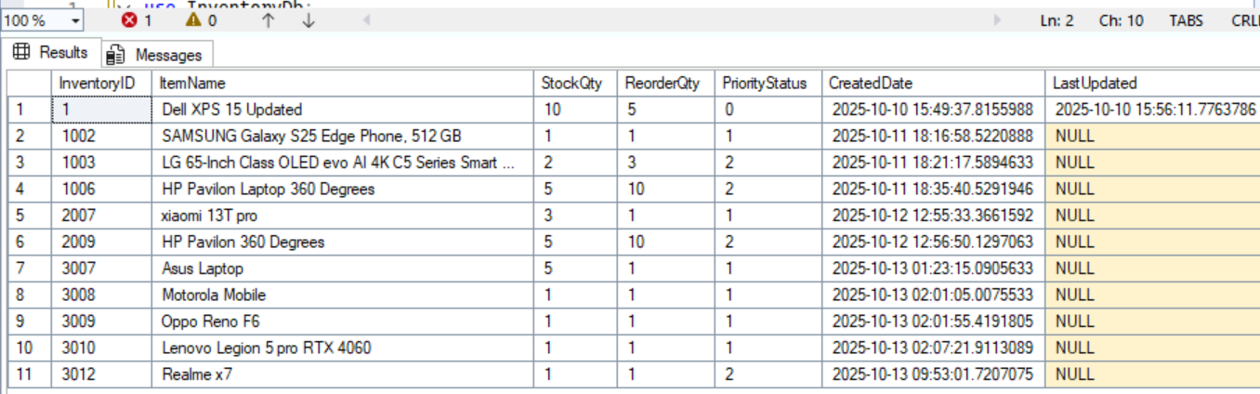

**Copilot responding with reviews:**

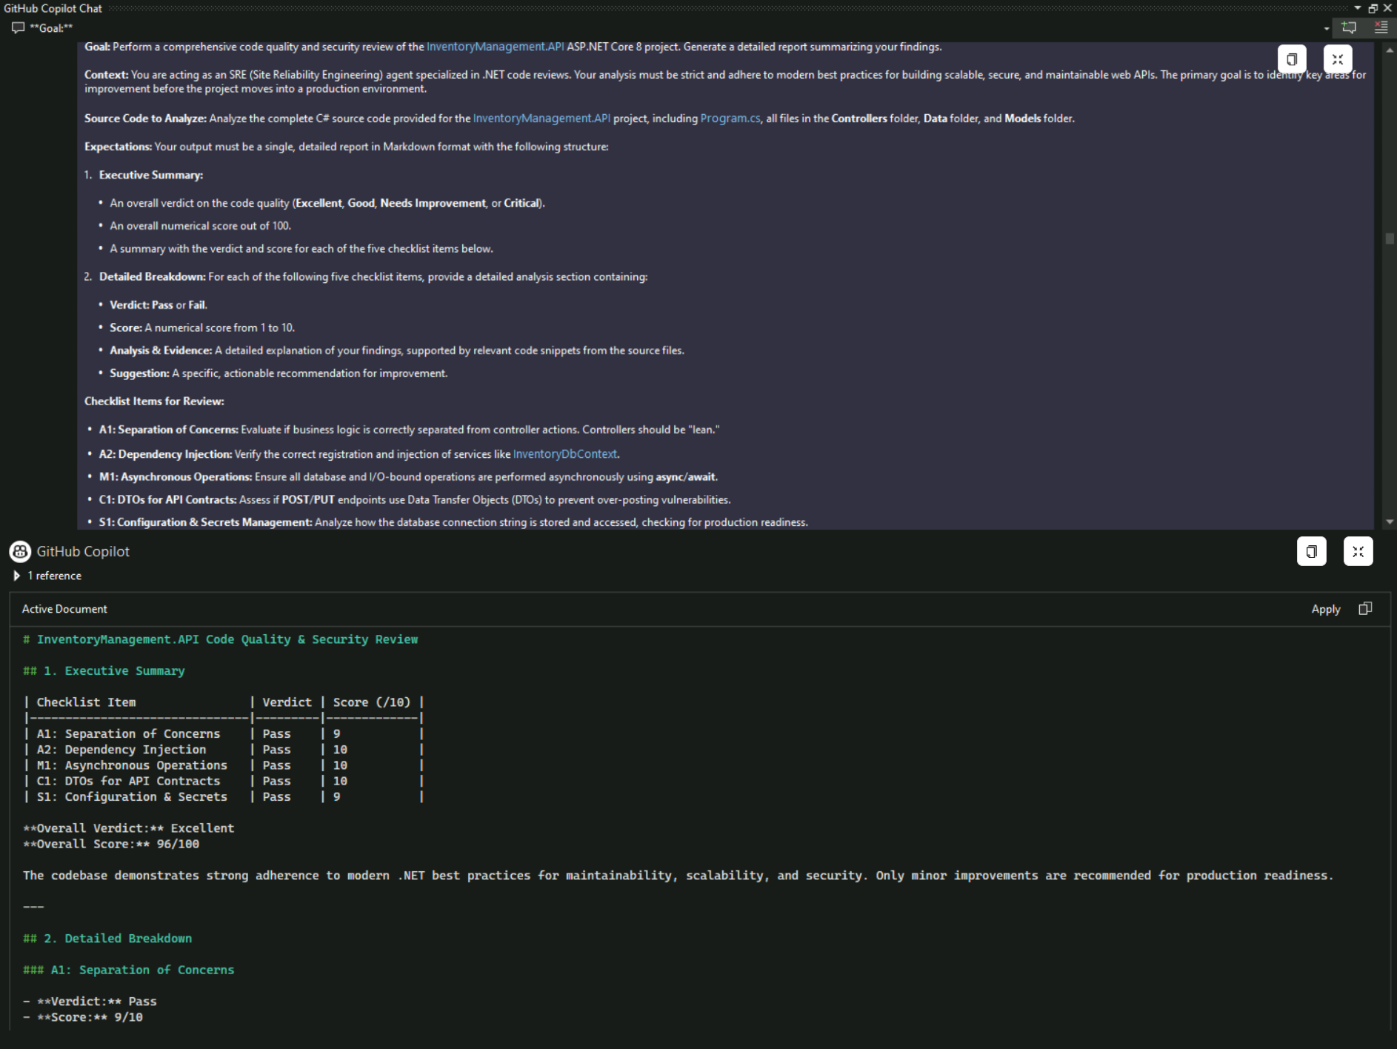

**FUTURE ENHANCEMENTS:**- Automated Pull Request Review System

- Role-Based Review Prompts

- Copilot-Driven Code Quality Dashboard

- Integration with Project Management Tools

- Copilot-Powered Documentation Generator

**Code Review Using GitHub Copilot**

TEAM GITHUB PILOTS

**Vishnu Priya P, Kumpatla Sai Chaitanya, Dheeraj Sai Tiwari, Gokul Siddarth S**

**S**

**,**

**Knowledge Sharing:** Standardized code reviews across repositories improves collaboration.

**Reduced Review Overhead:** Cuts manual review cycles by up to 70%, freeing senior developers for strategic tasks.

**Enhanced Developer Productivity:** AI-driven suggestions reduce repetitive coding tasks.

**ARCHITECTURE DIAGRAM:**

**Project Workflow:**

**PROBLEM STATEMENT:**

- Manual inventory management causes errors and inconsistencies.

- No automated code quality checks during development.

- Poor coding standards lead to maintainability issues.

- Lack of systematic code review for enterprise-grade apps.

**OBJECTIVES:**

- Build a real-time inventory system with scalable architecture.

- Integrate GitHub Copilot for automated code review.

- Enforce industry-standard coding practices.

- Generate actionable quality reports.

**TECH STACK:**

**- Frontend:** Angular 20, TypeScript, Bootstrap.

**- Backend:** ASP.NET Core 8 Web API, Entity Framework Core, JWT Authentication, CORS.

**- Database:** SQL Server (LocalDB) via SSMS.

**-Tools:** GitHub Copilot, Swagger UI for API testing.

**BENEFITS:**

**- Efficiency:** 50% faster development, 70% reduced manual review effort.

**- Quality:** 90/100 overall score, full compliance with separation of concerns.

- Real-time tracking, **quality feedback** during development secure role-based access, scalable design.

**- Cross-Repository Standardization:** GitHub Copilot enforces consistent coding standards across multiple projects within the organization.

**- Reduced Onboarding Time:** New developers adapt faster with AI-driven code suggestions and best practices.

**- Automated Documentation:** Copilot assists in generating inline comments and API documentation, reducing manual effort.

**Policy-Based Reviews:** Automated checks aligned with organizational coding policies ensure compliance.

**Early Vulnerability Detection:** Identifies insecure patterns (e.g., hardcoded secrets, weak authentication) during development.

* **Improved Maintainability:** Enforces modular design and separation of concerns for long-term scalability.

**Testing & Validation**

* **Checklist-Based Testing:** Automated validation against predefined quality checklists.
* **Swagger Integration:** Ensures API endpoints are tested and documented for reliability.
* **Continuous Feedback Loop:** Real-time alerts for deviations from coding standards.

**Business Impact**

* **Operational Accuracy:** Eliminates stock discrepancies through real-time inventory updates.
* **Scalable Architecture:** Supports future expansion without major redesign.
* **Compliance & Audit Readiness:** Automated reports simplify audits and regulatory compliance.

